**CS 250 Midterm 2**

**Chapter 7:**

* 0-address (stack architecture) kept on run-time stack. (page. 142)
* 1-address limits each instruction to a single operand (page. 142)
* 2-address, an operation can be applied to a specified value instead of merely to the accumulator. (page. 143)
* 3-address, two input values and destination (page. 144)
* **An anti-dependence between J and K occurs when K writes a register or memory location that J reads and instruction J is executed first**
* **An output dependence occurs when J and K write the same register or memory location**
* 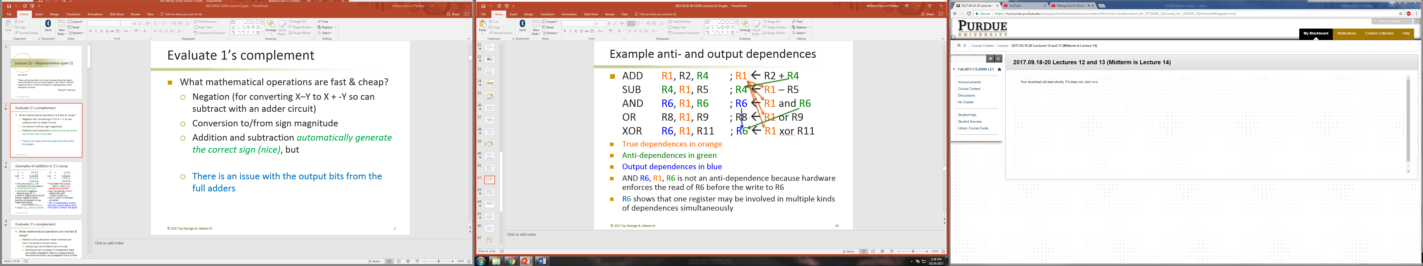
* 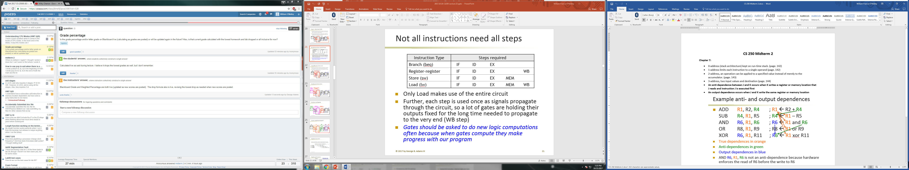
* **Pipelining *does* *not* improve execution time of any single instruction**
* **Each instruction takes *longer* to execute than in a single-cycle datapath because of**
* 